Correlation and regression analysis
Correlation analysis is understood as the study of patterns between phenomena (processes); the task of correlation analysis includes establishing a relationship between dependent and independent variables, finding mathematical descriptions of these relationships in the form of regression equations, assessing the closeness of relationships and the reliability of the results obtained. In general, the degree of relationship between two variables can be characterized by the following dependencies: independent, stochastic, correlation, functional.
Correlation dependence is a special case of stochastic, each value of one quantity corresponds to different average values of the other.
Functionally dependent values are those in which each value of one value corresponds to a well-defined value of another. (Functional dependence is a special case of correlation, when the measure of the closeness of the relationship between variables, determined by the correlation coefficient, is equal to one).
Stochastic connections can be complex. The simplest and most important type of stochastic relationship is correlation, which is expressed in the fact that the other reacts to a change in one random variable by changing its mathematical expectation or average value.
Thus, the concept of correlation is narrower in comparison with stochastic, since mathematical expectation is only one of the distribution parameters and does not determine the distribution law as a whole.
To find a mathematical description of these relationships means to get a mathematical model of the object. The task of correlation and regression analysis includes obtaining a mathematical model of an object (process) based on experimental data and analyzing it. The value of the mathematical model lies in the fact that it can be used to solve the problems of optimizing the process and predicting the results when the conditions of its course change (the second problem is called interpolation).
Correlation analysis is applicable only for such parameters that are interrelated when studying the physical nature of an object. At the first stage of the application of these methods, the degree of closeness of the relationship of the response function values with one or more independent variables is usually assessed.
It is convenient to illustrate what has been said geometrically, for which we consider a system of two random variables: X (x, , x2 , xn)
and y 0',, y2.....y "Y
Let's assume that as a result of the performed studies of various systems of random variables X and Y, some results have been obtained, which are graphically presented in Figure 2.4.
The location of points on the graph (correlation field) indicates the existence or absence of a connection between factor (X) and productive (F) features.
In the first case (Fig. 2.4 a), each value of x/ corresponds to the value of yi, moreover, the obtained random points are scattered on the field of coordinates x, y chaotically and no pattern is visible. Mr. Rafik clearly shows that the values of X and Y are not correlated (not related). At the same time, it cannot yet be argued that random variables are also independent. In probability theory, it is proved that the condition of independence of random variables is significantly more stringent than the condition of uncorrelation.

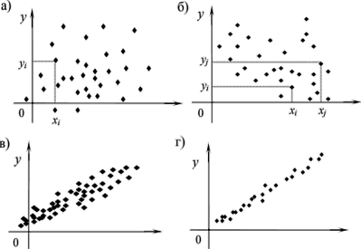
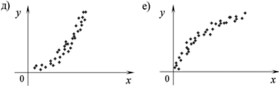

Figure 2.4. Correlation of random variables X and Y: a - no correlation; b - weak correlation; c - strong positive correlation; d - functional linear dependence; e, e - functional nonlinear dependencies
In the second case (Fig. 2.4 b), when the random variable X changes (increases), the value of Y also tends to change, decrease. This decrease, in general, despite the significant spread of points, is quite clearly visible. And although for each individual pair xi and yi, various deviations from the general trend are possible (for example, with Xj < Xi there should be yy < y,-, and on the graph yj > y,), but for the whole set of points it remains. In this case, we have a weakly pronounced negative correlation.
In the third case (Figure 2.4 c), a pronounced positive correlation is obvious, since with the increase of the random variable X and the value of Y also increases in general or on average. The fourth case (Fig. 2.4 g) illustrates an almost functional linear dependence of the magnitude of Y on the magnitude of X, moreover, this dependence is positive. A quantitative assessment of the degree of mutual connection (it is customary to talk about the closeness or strength of the connection) is given using the so-called correlation coefficient. Pair correlation coefficient.
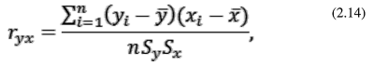
where y, X is the arithmetic mean of X^ and Y; in the sample under consideration;
Sy, Sx - their mean square deviations;
p is the sample size (usually and =50...200).
Let's denote the dependent variable by the digit 1, and the independent digits 2, 3, ..., t, then the coefficients of paired correlation will be written as follows: ri2, pz, ...rim, G23, G24, ..., and the coefficient of multiple correlation between y and *1, *2, ..." Xm-R,23...m-
Multiple correlation coefficient using the determinant method are found by the formula.
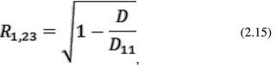
where D is the determinant composed of all the coefficients of the pair correlation,
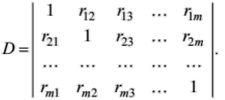
D n is the determinant obtained from D with the exception of the zero (first left) column and the zero (top) row.
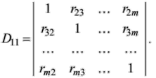
In the case of three variables
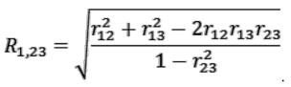

The values of guh and i?yxix2..xm are in the range from -1 to +1. If they are reliable, that is, they differ significantly from zero, then there is a linear correlation between the studied factors. Otherwise, this dependence is absent or is essentially nonlinear. If guh or /?yxix2...xm are equal to +1 or -1, which is extremely rare, there is a functional relationship between the studied factors. Guh and /? signsyxiX2...xm speak about the direct (+) or inverse (-) nature of the relationships between the studied factors. If correlation analysis confirms the existence of relationships between the studied factors, then at the next stage of processing experimental data using regression analysis, a mathematical model is chosen that best describes these relationships. The equation by which the numerical values of the sample mean functions of the click can be found for the corresponding values of the independent variables is called the regression equation. In general , it can be written as
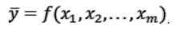
The operation of replacing one function with another, in some sense equivalent, is called approximation. When approximating unknown response functions in mathematical statistics, polynomial models are most often used. The degree of a polynomial is determined by the maximum degree of its variables.
We write out polynomials of various degrees for the case of two factors:
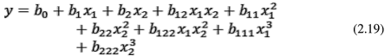
Regression equations of the form (2.16) and (2.17) are called linear, and of the form (2.18) and (2.19) are called nonlinear. Linear regression equations can be used at the first stage of studies of nonlinear correlations in order to introduce the necessary corrections into them in the future.
From the point of view of statistics, the polynomial model is convenient, since it allows you to increase the accuracy of the approximation by increasing the order of the polynomial. At the same time, the approximating function remains linear in parameters, which facilitates all statistical operations (using the least squares method to estimate parameters, choosing the optimal location of factor levels in the area of their change). The use of correlation and regression analysis is legitimate and effective if the following conditions
are met• * 1. The optimization parameter y is a random variable with a normal distribution law.
* 2. The variance of y does not depend on the absolute values of the magnitude of y, remains constant or homogeneous under different observations of y.
* 3. The values of the independent variables xv x2, ..., xt are measured with negligible errors compared to the error in determining y.
* 4. Variables X, X2, ..., xt are linearly independent.
* 5. The process of changing the dependent variable y is stationary random.
* 6. Experimental data are obtained from a number of independent tests, observations and form a random sample from this general population.
The fifth and sixth conditions are characteristic of the passive experiment, the rest are both passive and active.
The correlation field characterizes the type of relationship between g and y. By the shape of the field, it is possible to roughly judge the shape of the graph that characterizes rectilinear or curvilinear dependencies. Even for a fully expressed form of the correlation field due to the statistical nature of the relationship of the phenomenon under study, one value of l; may have several values of y.
Therefore, the optimal function will be one in which the least squares conditions are met:
where yi are the actual ordinates of the field; y is the average value of 3 1 ordinates with an abscissa x.
With rectilinear correlation , the correlation field is approximated by the equation of a straight line
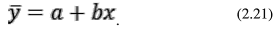Let's define the coefficients a, b so that the condition (2.20) is fulfilled. As you know, a necessary condition for a function to acquire a minimum value is that its first derivative (or partial derivatives for a function of many variables) is equal to zero.
Denote (p - 5jj=lCyi & define
la la
derivatives ~- and ~— and equate them to zero:
give
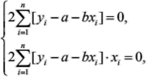
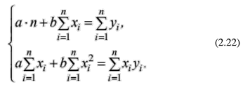
Solving the system (2.22) with respect to a and B, we obtain:
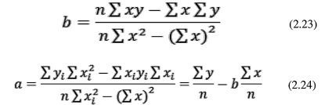
The criterion for the proximity of the correlation dependence between x and y to the linear functional dependence is the correlation coefficient G. It shows the degree of linearity of the relationship between x and y:
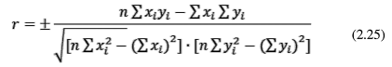
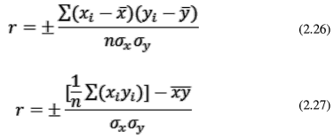
where n is the number of dimensions;
Gx Gy - standard deviations.
Despite the bulkiness of the formula (2.25), it is the simplest for calculations. The value of the correlation coefficient is always less than one. When r = 1.0, the values of x and y are connected by a functional relationship (in this case linear), that is, each value of x corresponds to one value of y. If r < 0.5, then there is no linear relationship, but there may be a nonlinear regression.
Usually, the tightness of the connection is considered satisfactory at g > 0.5, good - at g > 0.8 ... 1.0.
The least squares method can also be used in the case of nonlinear functions. So, when determining the parameters of the quadratic dependence
using the least squares method, we obtain a system of normal equations:
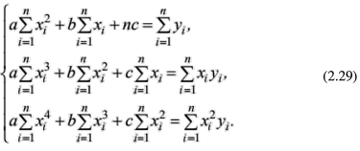
From this system, you can find the parameters a, B, C.
Analysis of variance
The presentation of the essence of correlation analysis is based on the assumption that the spread of observation results is mainly due to random causes. If the values of the input factors are changed in any natural way, then the task arises of assessing the degree of influence of such a change of each factor on the output of the process. Such problems are solved by the method of dispersion analysis.
Its essence is as follows. Let the output of some technological process be characterized by the influence of two factors A and B. In accordance with the rule of addition of variances for uncorrelated random variables, the total variance of the output of the process is equal to the sum of its components:
where O^total" ° is the total variance of the process output;
2 2
°A And (Jg - variances associated with the influence of factors A and B, respectively;
2
CT^g is the variance caused by the interaction of factors A and B;
((JqCT ~ residual, random part of the variance due to the influence of uncontrolled and unknown factors.
Similarly, we can present an expression for the total variance

(JqQiji with a large number of factors.
An important point is that in the analysis of variance, the variances of individual factors A, B, C ... are not associated with any random variable, since the values of the variables on the basis of which the variances are calculated are not random, but change in a given order.
The criteria for assessing the influence of individual factors on the output of the process can be both parametric (Student, Kohren - for a normal distribution) and nonparametric (Fisher, Pearson - for unknown distributions). For example, Fisher's nonparametric criterion is written
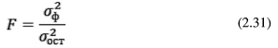Comparing the calculated value of F with the tabular one, do

they evaluate the reliability of the variances of individual factors ?7f (or their combinations) and their relative influence on the output of the process.

